**L.VARSHINI**

**192372045**

**CSA1618 DWDM-DE**

**EXPERIMENT-21**

**DATA PREPROCESSING AND ANALYSIS FOR DATASET USING WEKA AIM:**

To create data preprocessing and analysis for dataset using weka.

**PROCEDURE:**

1. Download and install WEKA.
2. Open WEKA and Choose "Explorer" from the main menu.
3. Under Preprocess, Click on the open file button and select the dataset.
4. Preprocess Data and analyse the attributes and missing values.
5. Save the file.

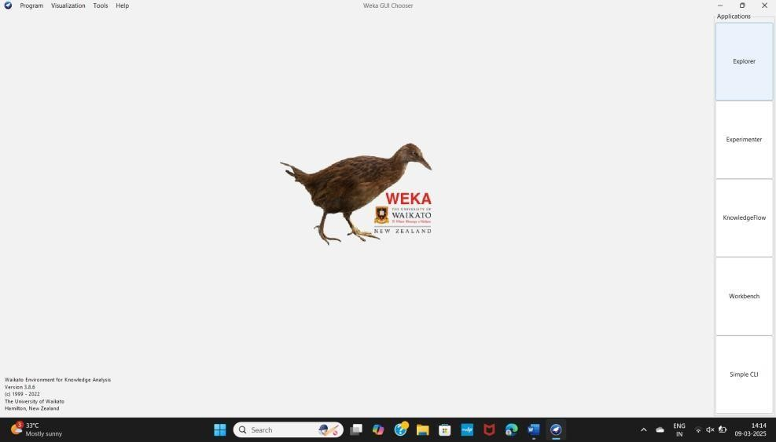

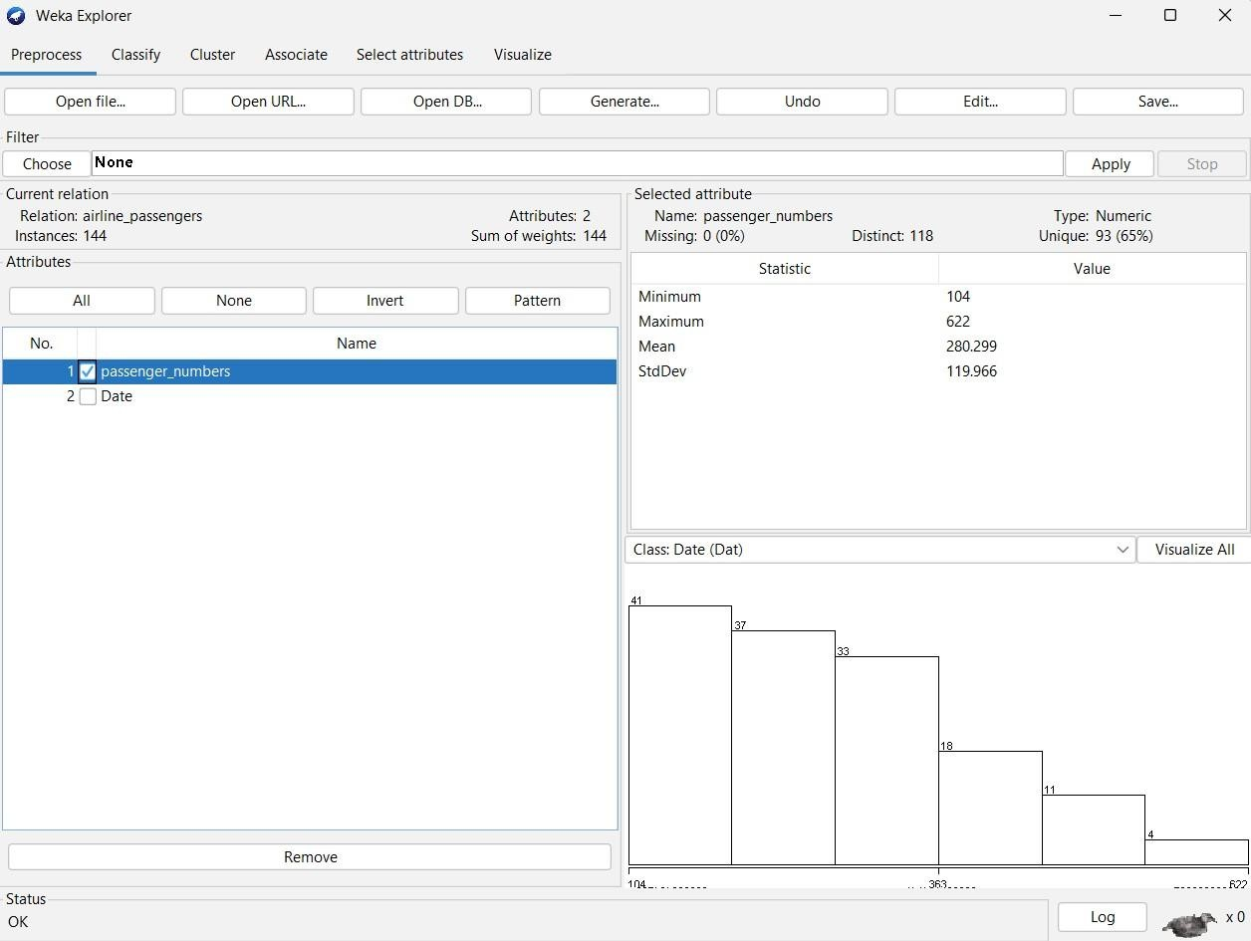

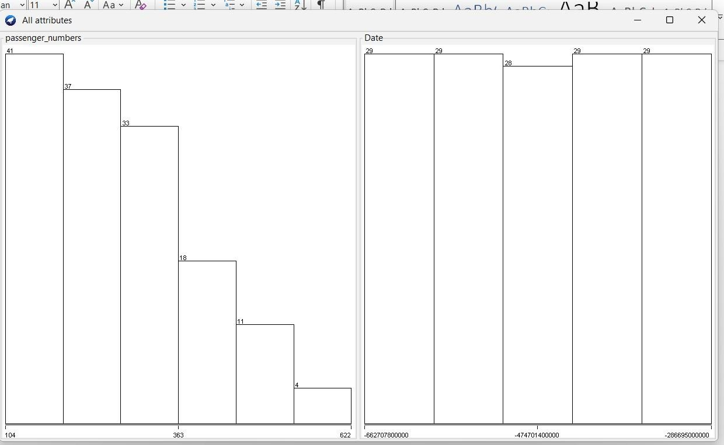

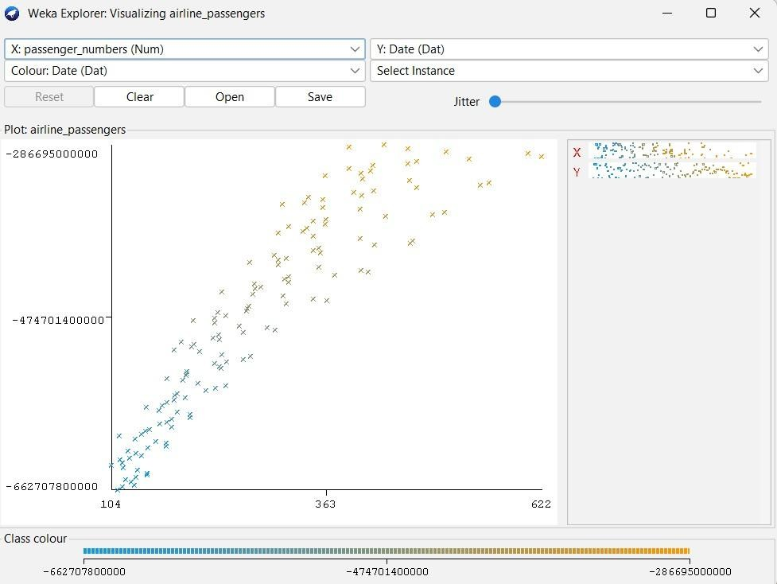

**OBSERVATION:**

Minimum - 104

Maximum - 622

Mean - 280.299 StdDev - 119.966

**RESULT :**

Thus, the dataprocessing and analysis for a dataset using weka tool has been successfully completed.